**FINANCIAL LOAN PROBLEM STATEMENTS**

1.Find Total Loan Applications Received by Bank?

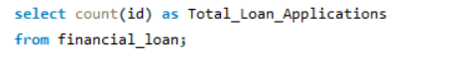

2.Calculate Month to date (MTD) loan Applications?

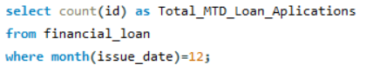

3.Find Previous moth to date loan applications?

4. Find Total Funded Amount Received by Bank?



5. Calculate Month to Date funded amont by Bank?

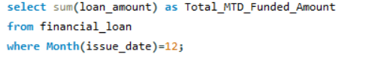

6. Find Total PMTD funded Amount by Bank?

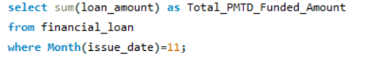

7.Calculate Total amount recived by Bank?

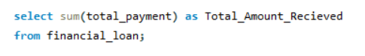

8.Calculate MTD amount received by Bank?

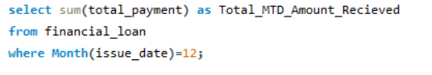

9.Calculate Total PMTD amount received by Bank?

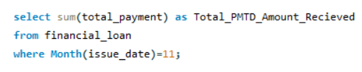

10.Calculate Total Average Intrest rate ?

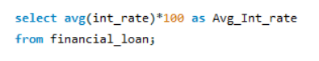

11.Find month to date Average Intrest rate?

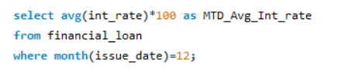

12.Calculate Average PMTD Intrest Rate?

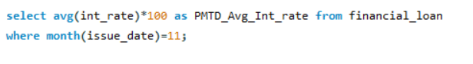13.Calculate Total Average DTI ?



14.Find month to date average DTI?

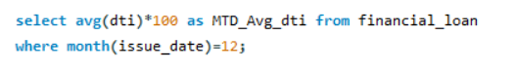

15.Calculate Average PMTD DTI?



16. What Percent of Good Loan issued by Bank?

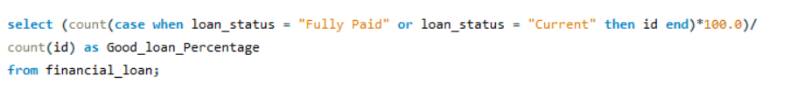17.How many Good Loan Applications are issued?

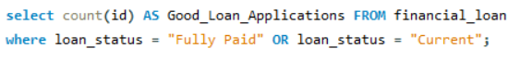18.How much Good Loan amount Funded?

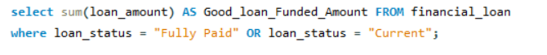

19.How much Total Good Loan Payments Received?

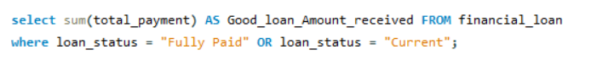

20.What percent of Bad Loan issued by Bank?

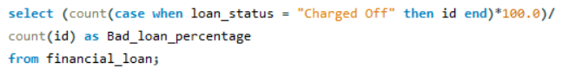

21.How many Bad Loan Appliactions are issued?

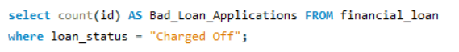

22.How much Bad Loan Amount Funded?

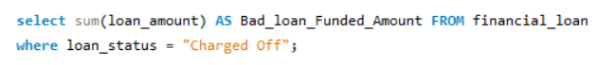

23.How much Total Bad Loan Payments Received?



24.Calculate applications,funded amount,total payments for each month?

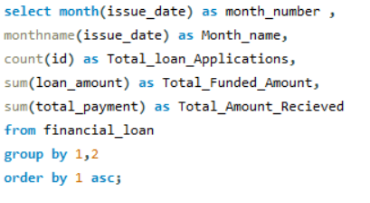

25.Calculate applications,funded amount,total payments for each State?

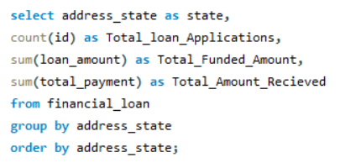

26.Calculate total applications ,funded amount,payments received by each Term?  
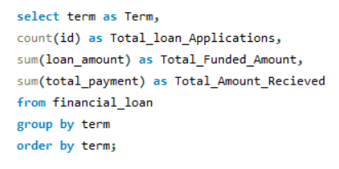

27.Calculate applications,funded amount,total payments for each Employ length?

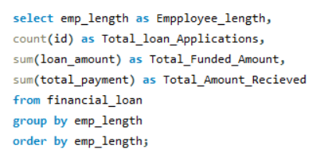

28.Calculate applications,funded amount,total payments for each Purpose?

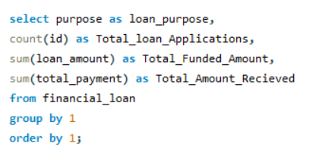

29.Calculate applications,funded amount,total payments for each Home owenrship?

